# **Willenburg Queen Upholstered Sleigh Bed**

**Details & Overview $589.99**

**Description**

Of great and sophisticated stature, the Willenburg queen upholstered bed is homey and full of substance. Exaggerated rolled tops on the headboard and footboard make a memorable statement. Textural upholstery is elevated with button tufting. Neutral linen color is ready to complement the bedding of your choice. Bun feet add the finishing touch. Mattress and foundation/box spring available, sold separately.

* Made of wood and engineered wood
* Includes headboard, footboard and rails
* Tufted headboard and footboard
* Polyester upholstery
* Assembly required
* Foundation/box spring required, sold separately
* Mattress available, sold separately
* Estimated Assembly Time: 55 Minutes

**Fabric Details**

* : POLYESTER (100)%

**Weight**

157 lbs. (71.21 kgs.)

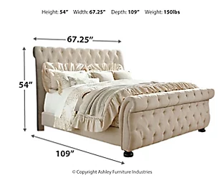**Dimensions**

* Width: 67.25"
* Depth: 105.00"
* Height: 32.50"

**Additional Dimensions**

* Queen upholstered rail (2) Width: 63.00"
* Queen upholstered rail (2) Depth: 85.00"
* Queen upholstered rail (2) Height: 13.00"
* Queen upholstered footboard Width: 67.25"
* Queen upholstered footboard Depth: 105.00"
* Queen upholstered footboard Height: 32.50"
* Queen upholstered headboard Width: 67.25"
* Queen upholstered headboard Depth: 12.00"
* Queen upholstered headboard Height: 54.00"
* Rail width Width: 58.00"
* Rail width Depth: 82.00"
* Rail width Height: 4.00"